SENTINELGUARD
SOC Monitoring, Identity Security & Risk Management Platform
SECURITY OPERATIONS CENTER — FINAL REPORT
Classification: CONFIDENTIAL
Report Date: June 18, 2026
Prepared by: SOC Analyst — Nimesh Nilakshan
Target System: DESKTOP-16UFKJN (192.168.56.1)
Incident ID: INC-2026-001

Contents

1. Executive Summary 3
2. Lab Environment & Tools Used 4
2.1 Architecture -: 4
2.2 Tools Used -: 5

3. Identity & Access Management 5
3.1 Simulated Employee Dataset -: 5

4. Endpoint Monitoring Configuration 7
4.1 Log Sources Configured 7
4.2 Key Event IDs Monitored 8

5. Password Security Audit 8
5.1 Password Audit Results: 9
5.2 Key Finding: 9

6. Threat Detection — Splunk Alerts 10
7. Attack Simulation 12
7.1 Attack Details: 12
7.2 Attack Events Generated in Splunk 13

8. Incident Investigation 13
8.1 Incident Summary: 13
8.2 Indicators of Compromise (IOCs): 14

9. Risk Assessment 15
9.1 Per-Account Risk Rating: 15
9.2 Risk Scoring Criteria: 16

10. Recommendations 17
10.1 Immediate Actions Required: 17
10.2 Short-Term Improvements (Within 30 Days): 17
10.3 Long-Term Security Improvements: 17

11. Conclusion 18

Executive Summary
This report documents the findings of a Security Operations Centre (SOC) assessment conducted on the SentinelGuard simulated enterprise environment. The assessment covered endpoint monitoring, identity and access management, password security auditing, threat detection, attack simulation, incident investigation, and risk assessment.

A brute-force attack was simulated from a Kali Linux machine targeting all five simulated employee accounts via SMB (port 445). The attack generated 120 failed login events across all targeted accounts. No successful unauthorized login was confirmed. Two employee accounts were identified as critically vulnerable due to weak, easily crackable passwords.
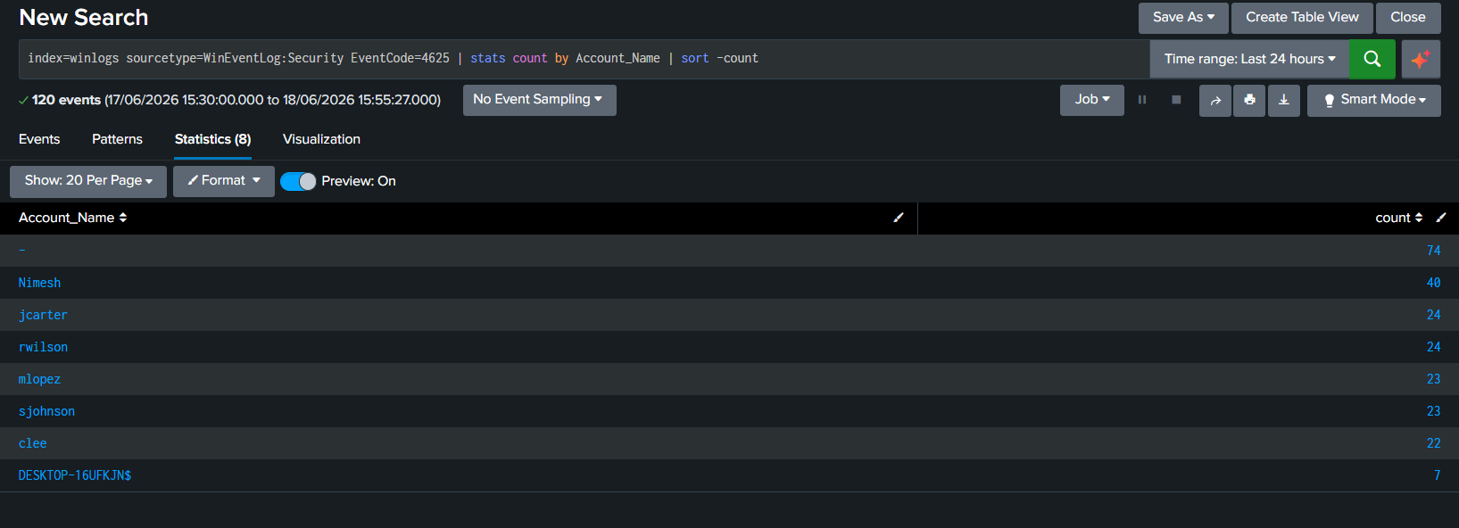

Figure 1: Failed Login Count

Metric | Value
Assessment Date | June 18, 2026
Target System | DESKTOP-16UFKJN (192.168.56.1)
Total Accounts Audited | 5 employee accounts
Total Failed Login Events | 120
Successful Unauthorized Logins | 0 — No breach confirmed
Passwords Cracked | 2 of 5 (jcarter, rwilson)
Overall Risk Rating | HIGH

Lab Environment & Tools Used

Architecture -:
Host Machine: Windows 11 (real host) — Target system running Splunk Enterprise, Sysmon, and Windows Security Auditing.
Attack Machine: Kali Linux (VirtualBox VM, Host-Only Adapter, 192.168.56.x subnet).
Communication: Isolated Host-Only virtual network — no exposure to home/external network.

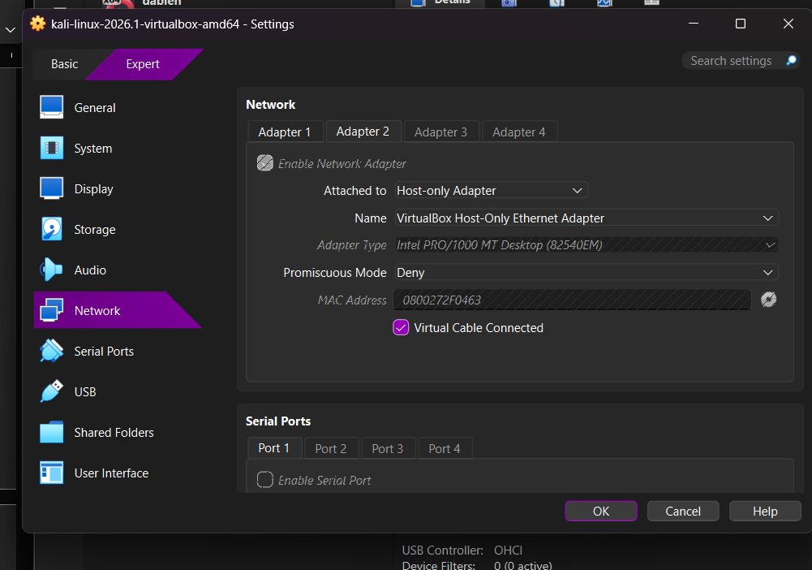

Figure 2: VirtualBox Network

Tools Used -:

Tool | Purpose | Location
Splunk Enterprise | SIEM — Log ingestion, search, alerting | Windows Host
Sysmon | Endpoint telemetry (process, network, file) | Windows Host
netexec | SMB brute-force attack simulation | Kali Linux
John the Ripper | Password hash cracking audit | Kali Linux
OpenSSL | SHA-512 password hash generation | Kali Linux
Windows Event Logs | Security, System, Application logging | Windows Host

Identity & Access Management

Simulated Employee Dataset -:
A dataset of 12 simulated employees was created across 5 departments to represent a realistic small-company environment. Five of these accounts were created as real local Windows accounts for attack simulation and log generation purposes

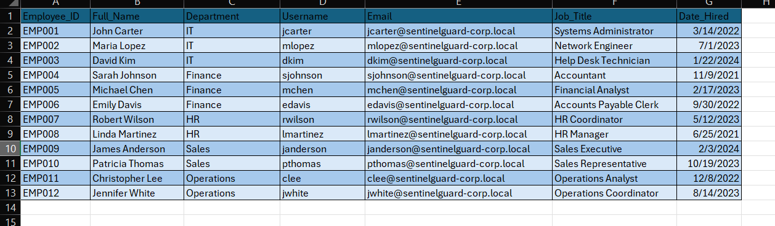
Figure 3: employees.csv file

Account | Full Name | Department | Job Title | Risk Level
jcarter | John Carter | IT | Systems Administrator | HIGH
rwilson | Robert Wilson | HR | HR Coordinator | CRITICAL
mlopez | Maria Lopez | IT | Network Engineer | MEDIUM
sjohnson | Sarah Johnson | Finance | Accountant | MEDIUM
clee | Christopher Lee | Operations | Operations Analyst | MEDIUM

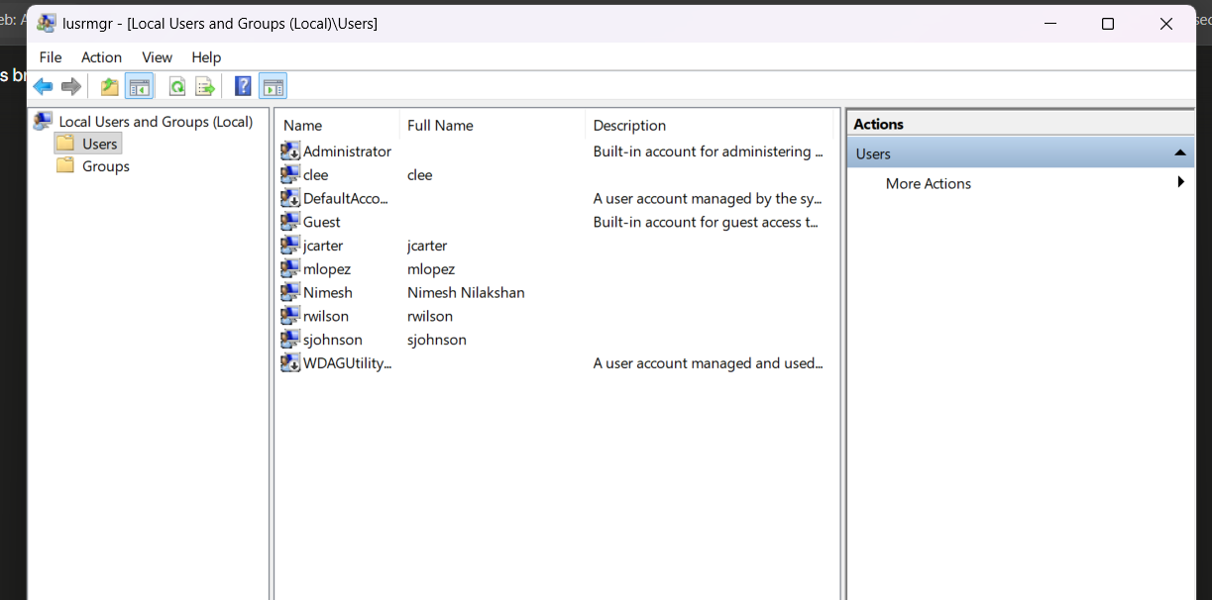

Figure 4: Windows Local Users

Endpoint Monitoring Configuration

Windows 11 was configured with Sysmon and Windows Security Auditing to generate detailed telemetry. All log sources were forwarded into Splunk Enterprise for centralized analysis.

Log Sources Configured

Source | Splunk Sourcetype | Events Collected
Windows Security Log | WinEventLog:Security | 9000+
Windows System Log | WinEventLog:System | 600+
Windows Application Log | WinEventLog:Application | 400+
Sysmon Operational | xmlwineventlog | 37000+

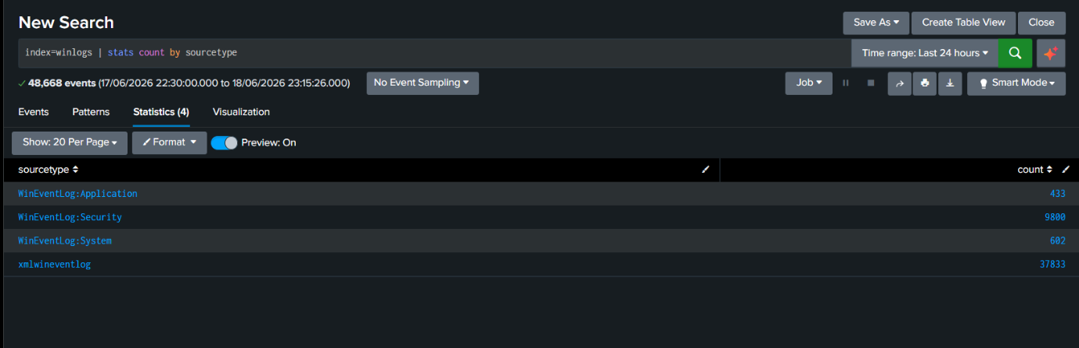
Figure 5: showing all 4 sourcetypes with their event counts

Key Event IDs Monitored

- EventCode 4624 — Successful logon
- EventCode 4625 — Failed logon attempt
- EventCode 4672 — Special/elevated privileges assigned
- Sysmon Event 1 — Process creation
- Sysmon Event 3 — Network connection
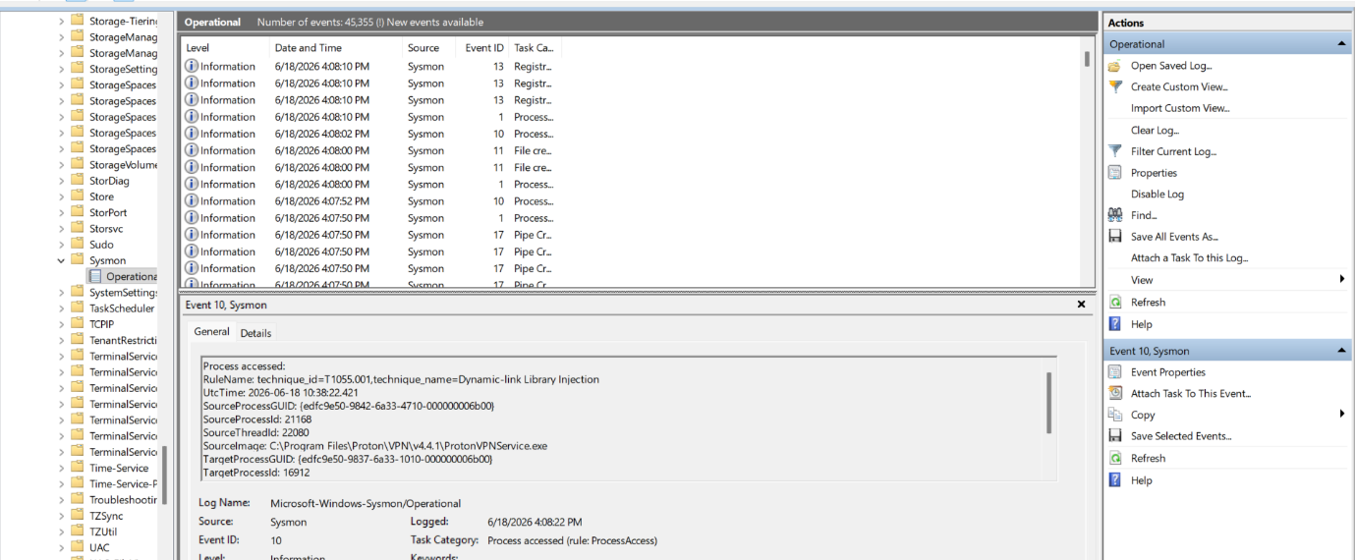

Figure 6: showing live Sysmon events

Password Security Audit

A password security audit was performed using John the Ripper against SHA-512 hashed versions of the 5 employee account passwords. The rockyou.txt wordlist (14+ million entries) was used as the attack dictionary

Figure 7: output showing jcarter

5.1 Password Audit Results:

Account | Password | Length | Upper | Lower | Num | Special | Cracked?
Jcarter | Password123 | 11 | Yes | Yes | Yes | No | YES
Rwilson | 123456 | 6 | No | No | Yes | No | YES
Mlopez | Summer2024! | 11 | Yes | Yes | Yes | Yes | No
Sjohnson | Tr0ub4dor&3xQp9! | 16 | Yes | Yes | Yes | Yes | No
Clee | K7#mP9$vL2qX | 12 | Yes | Yes | Yes | Yes | No

5.2 Key Finding:

2 of 5 accounts (40%) had passwords crackable within seconds using a standard dictionary attack. rwilson used '123456' one of the most common passwords globally. jcarter used 'Password123' a predictable dictionary word with number suffix. Both would be cracked in a real-world attack within minutes.

Threat Detection — Splunk Alerts

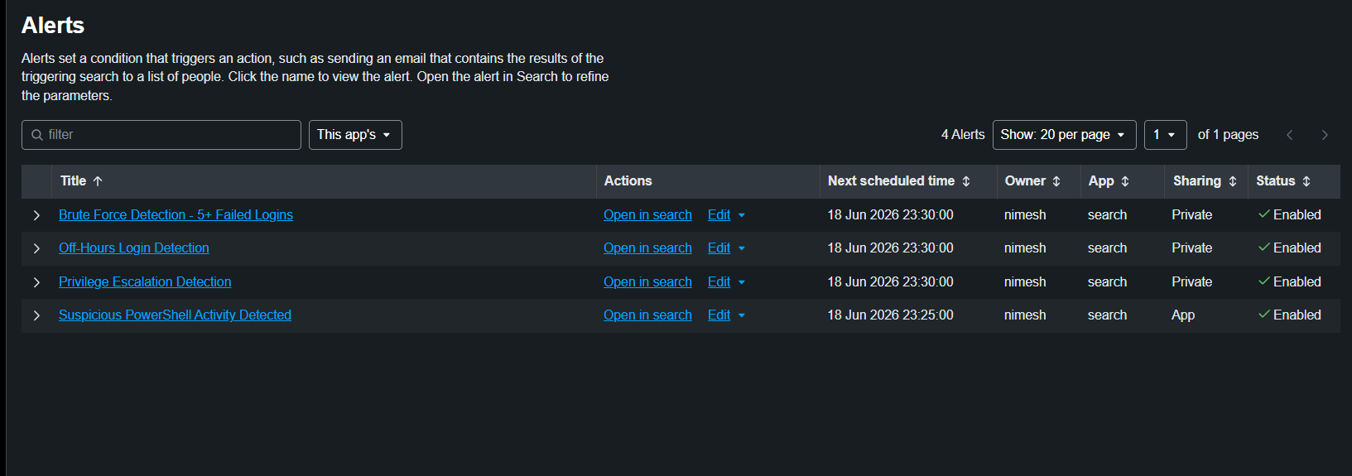
Three automated detection alerts were configured in Splunk to monitor for active threats in real time. All alerts run on a 15-minute Cron schedule.

Figure 8: Splunk Alerts

Alert Name | Detection Logic | Severity | Schedule
Brute Force Detection | 5+ failed logins (EventCode=4625) within 5-min window | HIGH | Every 15 min
Privilege Escalation Detection | EventCode=4672 for non-system accounts | HIGH | Every 15 min
Off-Hours Login Detection | EventCode=4624 outside 09:00–18:00 for real users | MEDIUM | Every 15 min

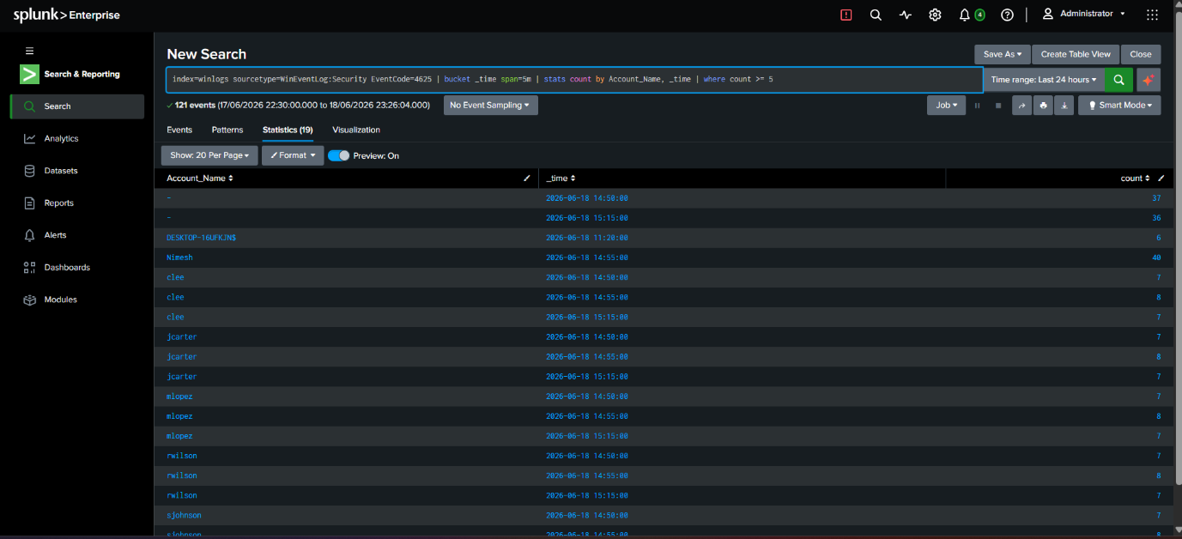
Figure 9:Splunk Search showing brute force threshold

Attack Simulation

Attack Details:

Field | Detail
Attack Type | SMB Brute-Force Authentication Attack
Tool | netexec v1.x (Kali Linux)
Source | Kali Linux VM (VirtualBox Host-Only Network)
Target | 192.168.56.1 — DESKTOP-16UFKJN (Windows 11)
Port | TCP 445 (SMB — Microsoft Directory Services)
Accounts Targeted | jcarter, mlopez, sjohnson, rwilson, clee
Wordlist | 7 common passwords per account = 35 total attempts
Date/Time | 2026-06-18 starting 11:24
Outcome | STATUS_LOGON_FAILURE on all attempts — no breach
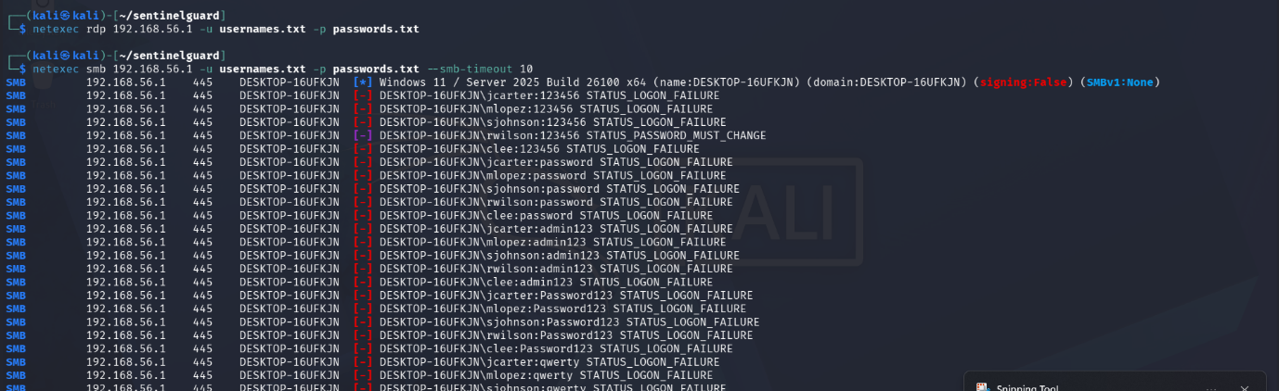

Figure 10: netexec output

Attack Events Generated in Splunk

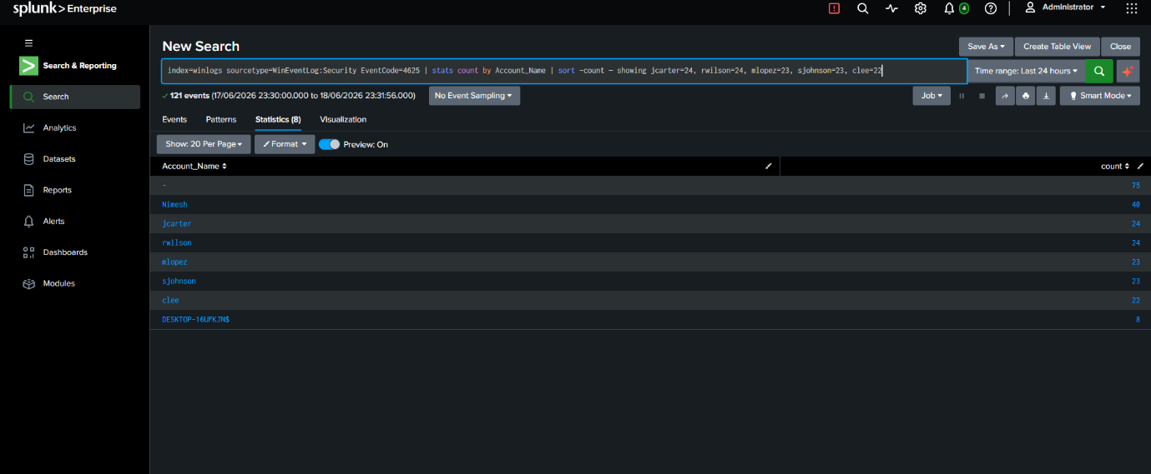
Figure 11: showing failed login counts

Incident Investigation

Incident Summary:

Field | Detail
Incident ID | INC-2026-001
Detection Method | Splunk Brute Force Detection Alert
Attack Start Time | 2026-06-18 11:24
Attack End Time | 2026-06-18 11:25 (approx)
Affected Accounts | jcarter, mlopez, sjohnson, rwilson, clee
Total Failed Logins | 120 (across all accounts)
Successful Logins Detected | None — no breach confirmed
Privilege Escalation | None detected on employee accounts
IOC | Rapid sequential SMB login failures across all accounts

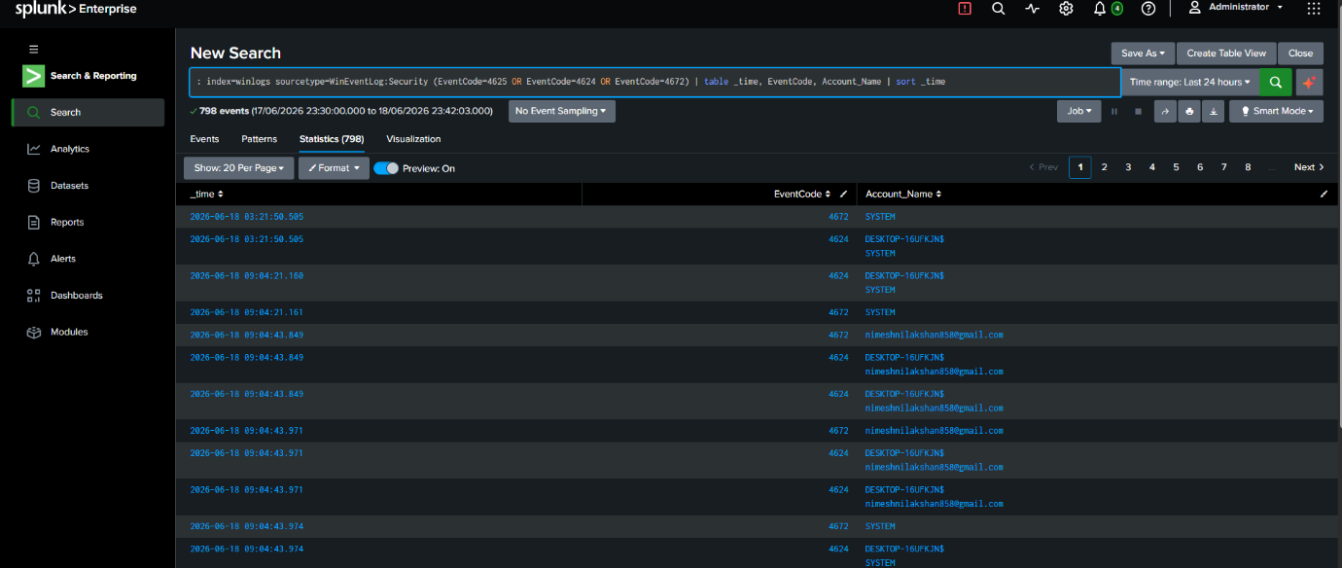

Figure 12: showing the attack timeline

Indicators of Compromise (IOCs):

- High-volume sequential failed login attempts across multiple accounts within seconds
- All 5 employee accounts targeted simultaneously — characteristic of automated credential stuffing
- SMB protocol (port 445) used as attack vector
- Attempts covered both weak and strong passwords equally consistent with wordlist attack

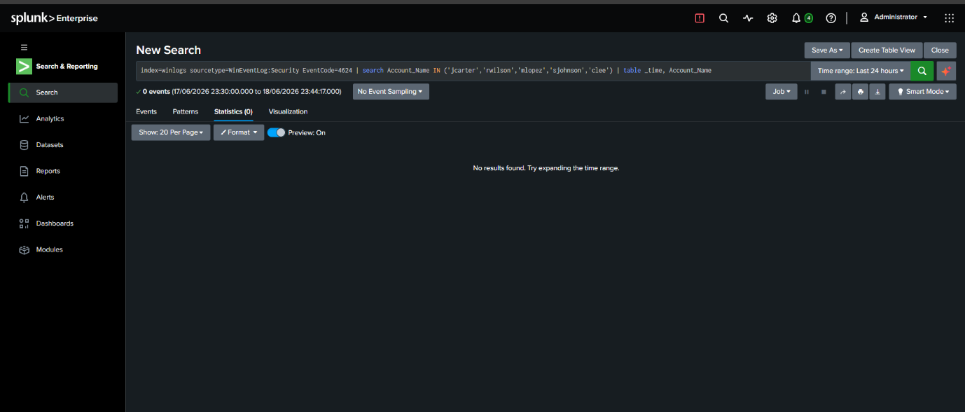
Risk Assessment

Figure 13: showing 0 results (no successful breach)

Per-Account Risk Rating:

Account | Department | Failed Logins | Pwd Cracked | Breach | Priv Esc | Risk
Rwilson | HR | 24 | YES (123456) | No | No | CRITICAL
jcarter | IT | 24 | YES (Pwd123) | No | No | HIGH
Mlopez | IT | 23 | No | No | No | MEDIUM
Sjohnson | Finance | 23 | No | No | No | MEDIUM
Clee | Operations | 22 | No | No | No | MEDIUM

Risk Scoring Criteria:

Factor | Low | Medium | High | Critical
Failed Logins | 1–4 | 5–9 | 10–19 | 20+
Password Cracked | No | No | Yes | Yes + Trivial
Breach Confirmed | No | No | No | Yes
Privilege Escalation | No | No | Attempted | Succeeded

Overall System Risk Rating: HIGH
Two accounts have crackable passwords, all 5 were actively targeted in a brute-force attack, and SMB authentication is accessible from the internal network. No breach was confirmed during this assessment, but the exposure is significant.

Recommendations

Immediate Actions Required:

- Force password reset for rwilson and jcarter immediately both passwords were cracked in under 20 seconds
- Enforce minimum password length of 14 characters across all accounts
- Enable account lockout policy: lock after 5 failed attempts, 15-minute lockout duration
- Disable SMB access from non-essential internal hosts restrict port 445 via Windows Firewall

Short-Term Improvements (Within 30 Days):

- Deploy Multi-Factor Authentication (MFA) for all employee accounts
- Implement a password complexity policy banning dictionary words, sequential numbers, and seasonal patterns
- Conduct regular password audits using John the Ripper or similar tools on a monthly basis
- Block known weak passwords using a banned password list (e.g., reject top-10000 common passwords)

Long-Term Security Improvements:

- Expand Splunk monitoring to include network-level events (DNS, firewall logs)
- Implement a privileged access management (PAM) solution for admin accounts
- Add anomaly-based detection (baseline normal behaviour, alert on deviations)
- Schedule quarterly red team exercises to continuously test detection capabilities
- Deploy endpoint detection and response (EDR) solution for deeper endpoint visibility

Conclusion

The SentinelGuard SOC assessment successfully demonstrated an end-to-end security operations workflow: environment setup, endpoint monitoring, identity management, password auditing, threat detection, attack simulation, incident investigation, and risk assessment.

The most significant finding is that 40% of audited accounts (jcarter and rwilson) have passwords that can be cracked within seconds using free, widely available tools. Combined with the confirmed brute-force attack surface via SMB, these accounts represent a high-priority remediation target.

The Splunk-based detection infrastructure successfully identified the attack patterns and generated actionable alerts. With the recommended improvements particularly MFA, account lockout, and password policy enforcement the overall risk posture of this environment would be significantly improved.

